NAME:-KHUSHAL PARISKAR

REGISTRATION NUMBER:-11912466

INT213 CA2PROJECT WORK

TOPIC:-ATTENDENCE MANAGEMENT USING GUI AND DBMS.

SUBMISSION DATE:-30-10-2020
LOGIN / SIGNING
UPDATE INFROMATION
ACCESS DASHBOARD
ADD A NEW USER
TECAHER INFORMATION
STUDENT INFORMATION
APPLY FOR LEAVES
UPDATE SCHEDULE
STUDENT ATTENDENCEF
ACCESS DASHBOARD
CHECK SCHEDULE
UPDATE PASSWORD
SIGN-IN
LOG-IN
STARTING PAGE
ACCESS DASHBOARD
APPLY FOR LEAVE
LOOK FOR ATTENDENCE
ATTEND THE CLASS
LOGIN->ADMINSTRATION
LOGIN->TEACHER
LOGIN->STUDENT

STARTING PAGE

- The Complete project will start from here.

- User will be provided with a button on which after clicking user will be directly directed to next page called login-signing page.

- LOGIN-SIGNING PAGE

- User will be asked the type of user it is and provided 3 options.
  - Student type.
  - Teacher type.
  - Administrative type.

- After selecting particular option, user will be directly transferred to respective selection page for making selection.
  - Student type-> student selection page.
  - Teacher type-> Teacher selection page.
  - Administrative type-> Admin selection page.

- SELECTION PAGES

- After entering into the Student selection page, Student will be provided certain options from which user have to make the choice. Options provided are:-
  - DASHBOARD.
  - TODAY’S CLASSES.
  - YOUR ATTENDENCE.
  - APPLY FOR LEAVE.
  - UPDATE PASSWORD.
  - LOG-OUT.

- After entering into the Teachers selection page, Student will be provided certain options from which user have to make the choice. Options provided are:-
  - DASHBOARD.
  - TODAY’S SCHEDULES
  - UPDATED TODAY’S SCHEDULES.
  - STUDENT ATTENDENCE.
  - APPLY FRO LEAVE.
  - LOG-OUT.

- After entering into the ADMIN selection page, Student will be provided certain options from which user have to make the choice. Options provided are:-
  - DASHBOARD.
  - STUDENT INFORMATION.
  - TEACHERS INFROMATION.
  - ADD NEW USER.
  - UPDATE PASSWORD.
  - LOG-OUT.

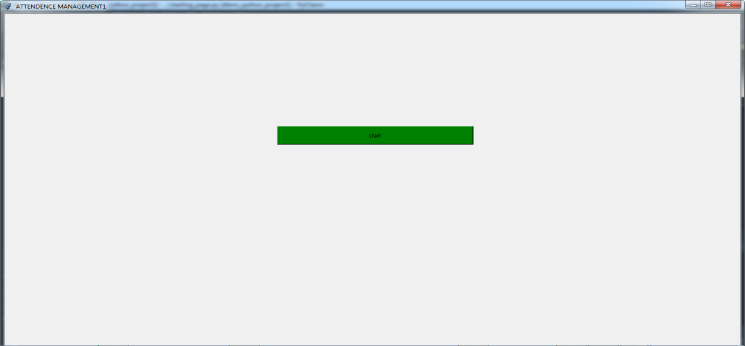

(starting page.)

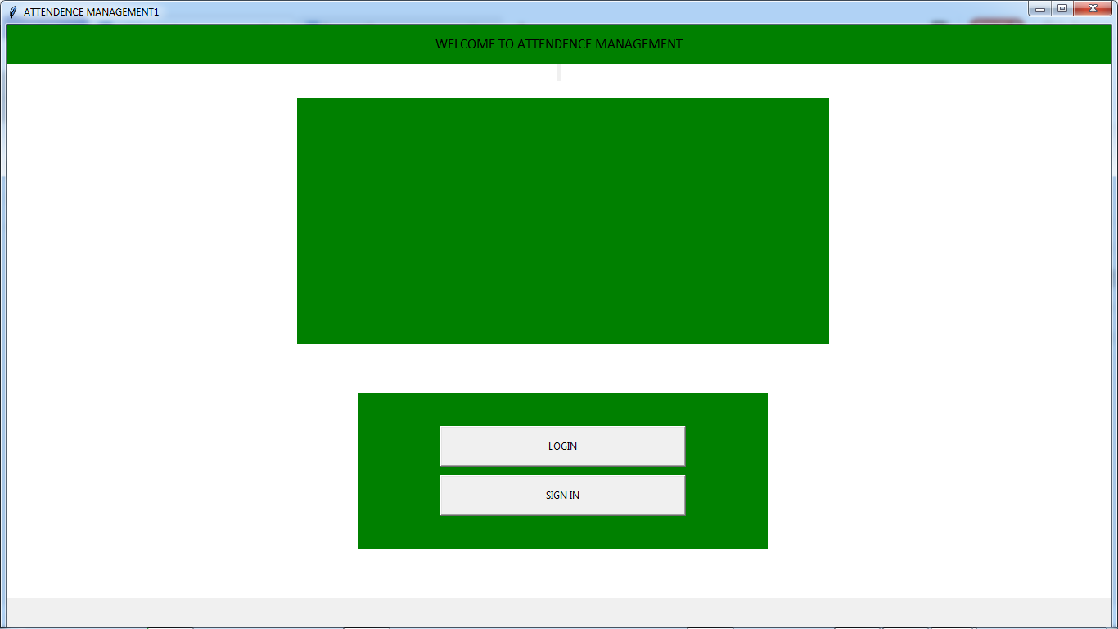

(login-signin)

SIGNING-IN

- Any new user’s first task is to sign-in.
- After clicking on the Start Button, user will be directed to login-signing page, where for the purpose of signing in, user has to click on SIGNING option.
- After signing in, user will be directed to the page where user have to provide the required information:-
  - Name.
  - Gender
  - Date of BIRTH
  - EMAIL ID
  - CONTACT NUMBER
  - Father’s name.
  - Mother’s name
  - Registration number.
  - PASSWORD.
- After proving the required information, user has to click on SAVE DATA mandatory, only after which user’s information will be saved into the database.
- After clicking proceed, user will be directed into the Academics details protofolio and after required information will be asked.
  - SESSIO.
  - COURSES
  - ROLL NUMBERS.
  - UPLOAD IMAGES.
  - UPLOAD IDENTITY.
- Once user has clicked on SAVE DATA, user’s data will be stored into the database.
- Then USer has to click on Proceed fro further process.
- After clicking on Proceed, user will be directly transferred into the login page where further process will take place.
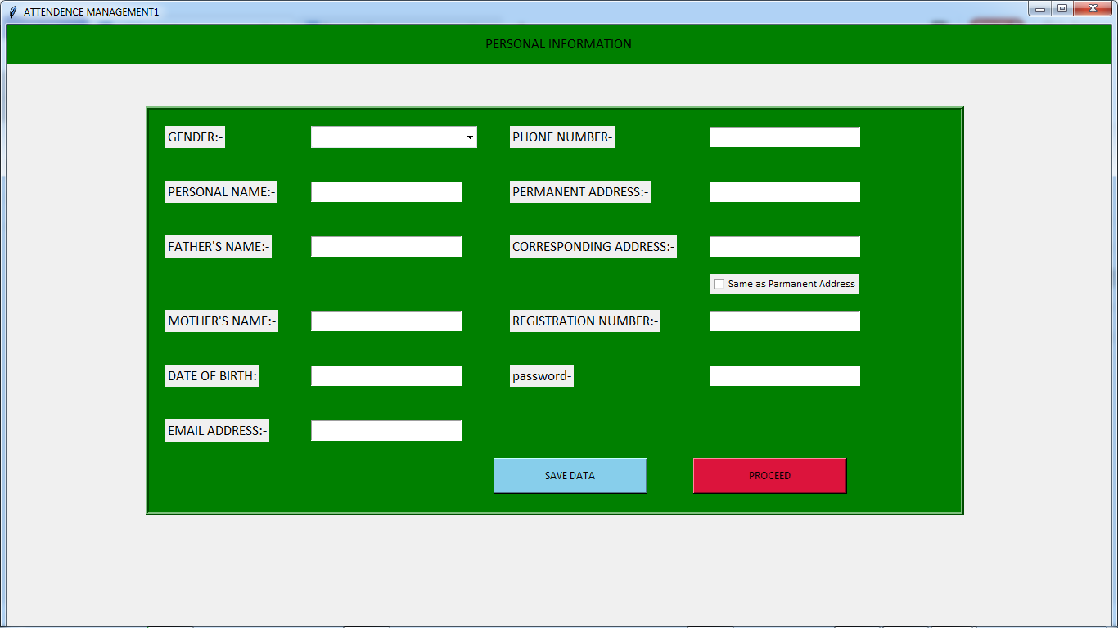

(signing page1)

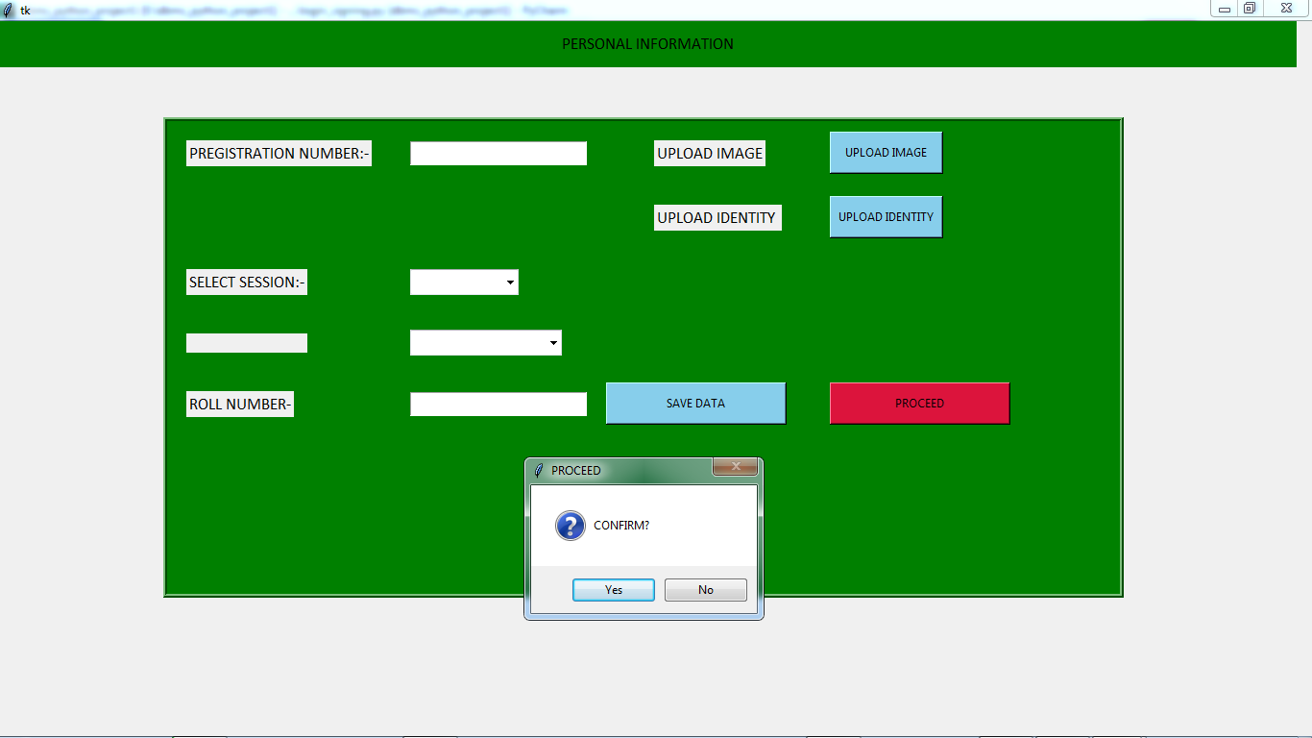
(signing page 2-> click on proceed-> transferred to logout window)

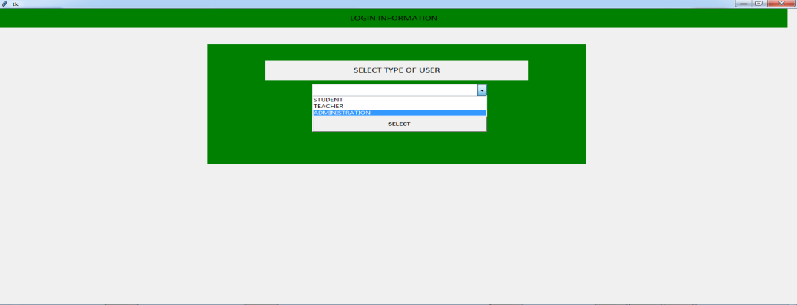

(logIN window)

LOGGING INFORMATION
SIGNING INFORMATION

TEACHER SELECTION PAGE
ADMIN SELECTION PAGE
STUDENT SELECTION PAGE
LOGGED IN SUCCESSFULLY
REGISTRATION NUMBER
PASSWORD
Save data
ALL REQUIRED ACADEMICS DETAILS.
PROCEED
ALL REQUIRED PERSONAL INFORMATION
ADDRESS AND EMAIL
CONTACT NUMBER
PASSWORD
REGISTRATION NUMBER
NAME

LOG-IN.

- After Sign-in, user will be directly directed into the Login page.
- User can also direct himself to the login page selecting the options on the login-signin page.
- First thing befor loggin, user have to select type of user.
  - Student.
  - Teacher.
  - Adminstration.
- In loggin page, User Registration number/Employ ID will be asked along with PASSWORD.
- In case if User’s password and registration number/ID doesnot match, user will get an error message box.
- If User’s id/password match, user will be logged in successfully and will receive the message for same.
- After successful Login, user wil be directed to respective selection page.
  - For Student user-> Student selection page.
  - For Teacher-> Teacher’s selection page.
  - For Adminstration-> Admin’s selection page.

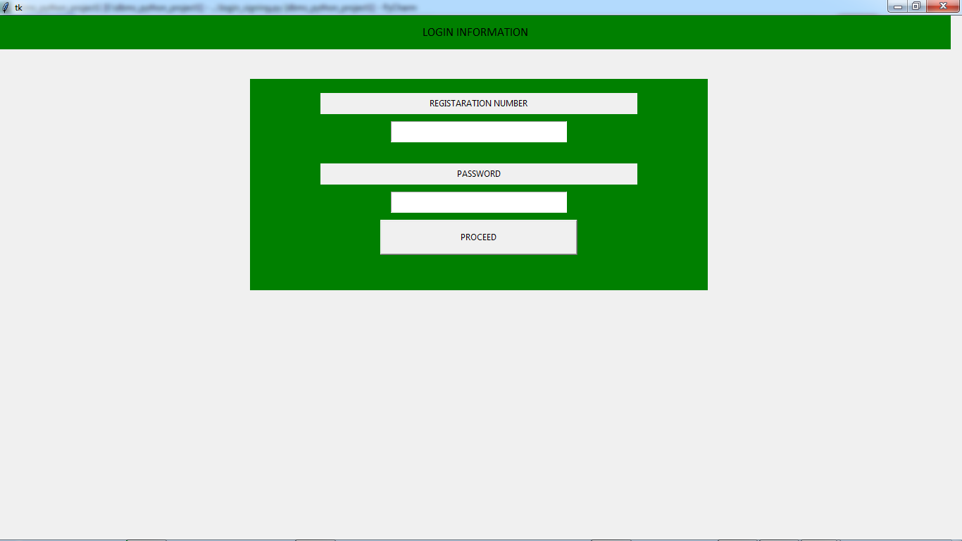
(logout window asking for registration number and password)

STUDENT SELECTION PAGE.

- A after successfully logging in as a STUDENT, user will be directed to the STUDENT SELECTION PAGE.
- STUDENT SELECTION PAGE mainly provides the choices in between functionality provided to the USER as a STUDENT.
- STUDENT SELECTION PAGE contains following options:-
  - DASHBOARD.
  - TODAY’S CLASSES.
  - YOUR ATTENDENCE.
  - APPLY FOR LEAVE.
  - UPDATE PASSWORD.
  - LOG-OUT.

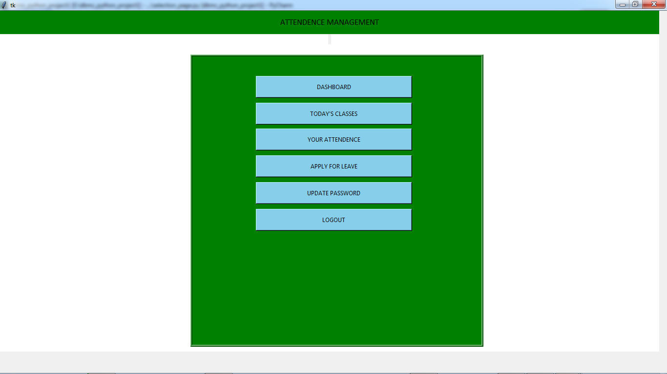
(Student selection window providing different options)
TODAY’S CLASSES
UPDATE PASSWORD
APPLY FOR LEAVE
YOUR ATTENDENCE
DASHBOARD
STUDENT SELECTION PAGE
STUDENT SELECTION

DASHBOARD.

- Student’s Dashboard mainly contain all the required information of the user which includes:-
  - User’s name along with registration number and roll number.
  - User’s Course and session he/she enrolled in.
  - User’s selected profile picture.
  - A Quote for daily motivation.
- A Frame directly dedicated for:-
  - easy access to TODAY’S CLASSES(timetable for classes our user needed to take.)
  - A Frame directly dedicated fro easy access to USER’S AGGREGATE ATTENDENCE.
  - A Frame directly dedicated fro easy access to news and announcement (In case if any).
  - User’s class, news and attendence will directly be managed without user’s concern.
- User will also be shown:-
  - DATE for next holiday.
  - DATE for next CA.
  - DATE for Mid-Term.
  - Date for End-Term.
  - Please note that, admin has to manually feed this thing up.
- User will also be shown a message box to receive any message in case, from faculty.
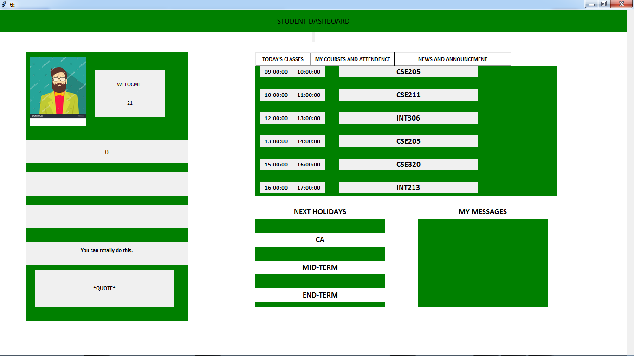
(student’s dashboard)

STUDENT SELECTION

TODAY’S CLASSES.

- The page of TODAY’S CLASSES will contain all the classes scheduled for the Student on that day.
- This is the main page for user to attend the class and mark the attendence
- All the classes in this page will be divided into 3 parts:-
  - Ongoing class.
  - Ended class.
  - Upcoming class.
- Here particular color frame are provided for easy understanding to the student.
  - RED color Frame-> for Ongoing class.
  - Blue color Frame-> for Upcoming class.
  - Grey color Frame-> for Ended classes.
- For a particular class Frame following thing were provided.
  - Class starting time.
  - Class ending time.
  - Class name.
  - Button1.
    - For showing the status in case of Ended class.
    - For Attending class for Ongoing class.
    - For setting up reminder for Upcoming class.
  - Button2.
    - For marking leave for Upcoming class.
    - For messaging class in Ongoing class.
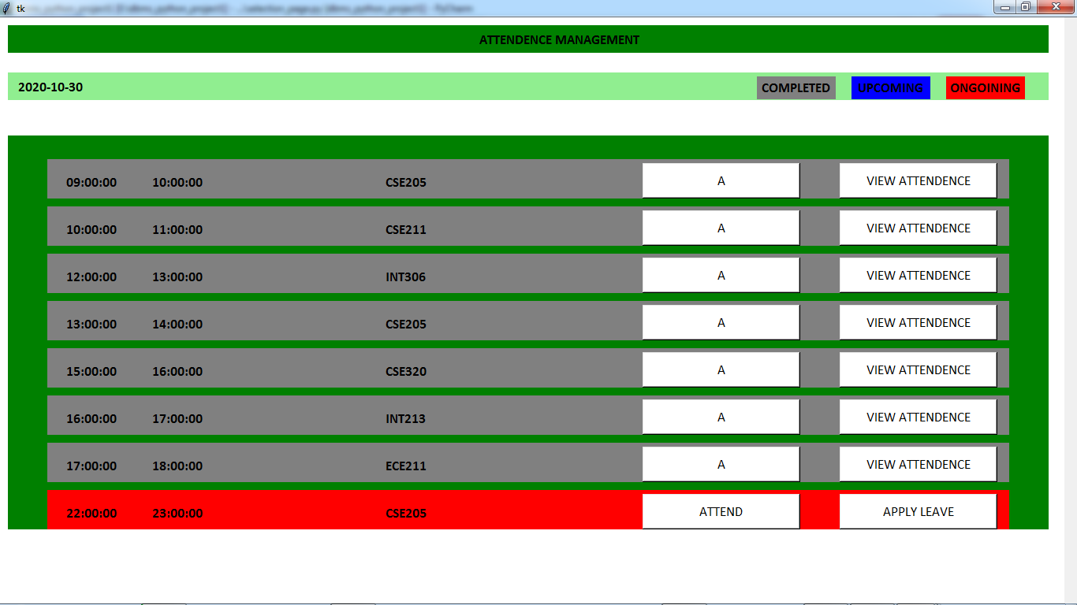
(all classes scheduled today, grey-> ended classes, red->ongoing class, blue-> upcoming class)
UPCOMING CLASSES
GREY
STATUS
COLOR
BLUE
REMINDER
APPLY
LEAVE
COLOR RED
PING FACULTY
ATTEND
CLASS
ONGOINING CLASSES
ENDED CLASSES
TUPES OF CLASSES
TODAY’S CLASSES
STUDENT SELECTION

- TODAY’S CLASS

- ONGOING CLASSES:-
  - Ongoing class Frame will show the class as per the schedule of the student at that particular point of time.
  - Ongoing class Frame will contain starting time, Ending time and Class name. It will also contain 2 Button for a)attending class b)Messaging faculty.
  - ON clicking Attending class user will directly directed to the new page solemnly dedicated for managing attendence with respective to that class.
  - On clicking Message faculty, user will be provided Entry box where they can type the message to user.
  - Ongoing class Frame will be Colored RED for easy understanding to the user.

- UPCOMING CLASSES:-
  - Upcoming class Frame will show the next class as per the schedule of the student at that particular point of time.
  - Ongoing class Frame will contain starting time, Ending time and Class name. It will also contain 2 Button for a)Set reminder b)Apply leave.
  - ON clicking Apply leave user will directly directed to the new page solemnly dedicated for managing leaves and user has to provide certain information will marking leave.
  - On clicking Set reminder, user will be provided New Label visible to user outside the Frame.
  - upcoming class Frame will be Colored BLUE for easy understanding to the user.

- ENDED CLASS:-
  - Ended class Frame will show the class as per the schedule that has ended for the student at that particular point of time.
  - Ended class Frame will contain starting time, Ending time and Class name. It will also contain Button for a)STATUS.
  - Status will show status I.e present/absent or leave of the student for that particular class.

STUDENT SELECTION

TODAY’S CLASSES --> ONGOINING CLASS --> ATTEND CLASS.

- In Today’s class section, after clicking on ATTEND CLASS Button which is presented on Ongoing class Frame, User will be directly transferred to Attend class page.
- ATTEND CLASS page is solemnly dedicated for managing and calculating the attendence of the student.
- Attended Class Page contains:-
  - Rules for marking the attendence as PRESENT.
  - Button LEAVE CLASS which user have to mark mandatory for punching the attendance and commiting the task.
  - A Frame dedicated for messaging the Faculty.
  - Another Frame to show the status.This Frame contains
    - CLASS STARTING TIME.
    - CLASS ENDING TIME.
    - TIME YOU JOINED THE CLASS.
    - UPDATING COUNTER SHOWING THE TIME USER SPENT IN THE CLASS BEFORE LEAVING.
    - 4 STATUS LABEL.
      - This status will get updated as per the rule as present or absent.
      - (conditions discusses later.)

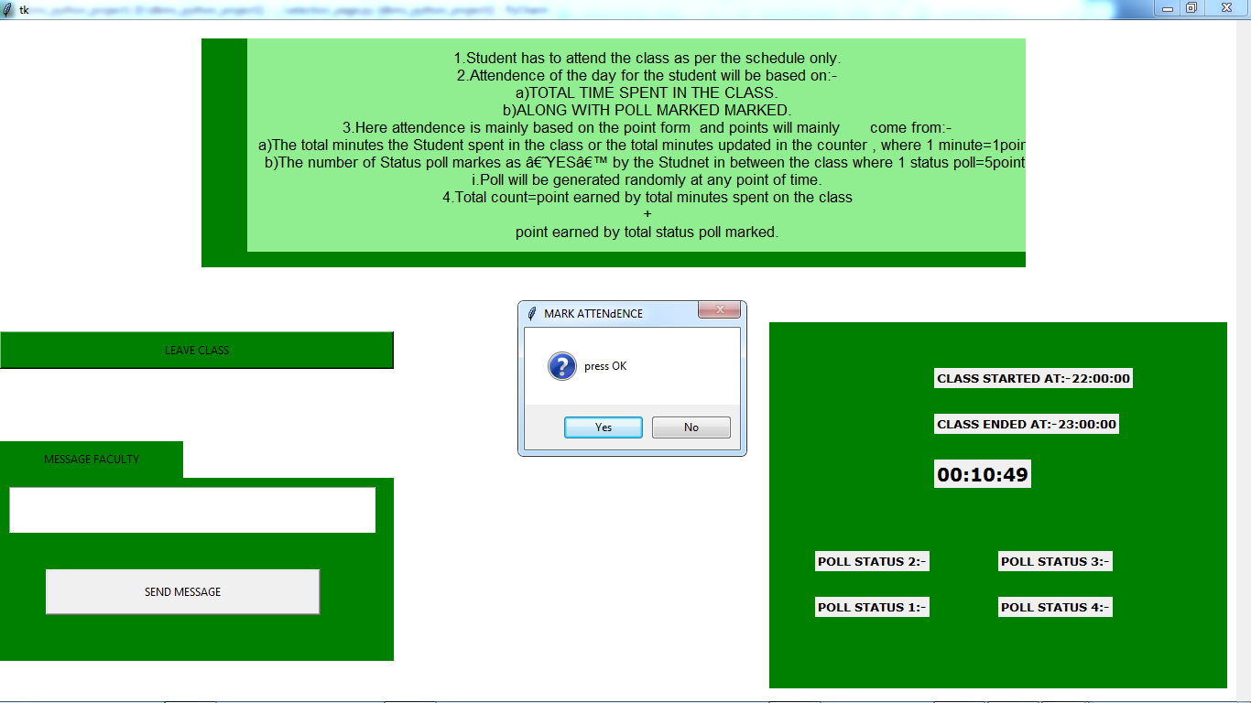
(status window+message+rules +poll avaialale fro attending class)
ATTENDENCE CALCULATION.

RULES AND CONDITIONS.

- Student has to attend the class as per the schedule only.
- Attendence of the day for the student will be based on:-
  - TOTAL TIME SPENT IN THE CLASS.
  - ALONG WITH POLL MARKED MARKED.
- Here attendence is mainly based on the point form and points will mainly come from:-
  - The total minutes the Student spent in the class or the total minutes updated in the counter , where 1 minute=1point.
  - The number of Status poll markes as ‘YES’ by the Studnet in between the class where 1 status poll=5point.
    - Poll will be generated randomly at any point of time.
- Total count=point earned by total minutes spent on the class
+
point earned by total status poll marked.
- Total minimum count required by the student to marked present= 50 points.
- If user will get less than 50 point, he will be marked as absent.
- If user will get more than equal to 50 point, he will be marked as present.
- Once the User will clicked Leave class user’s Status will be stored into the Table presented In DATABASE.
- For calculating the aggregate attendence of student after leaving the class following formula will be used:-
  - Aggregate attendence=
(total class attended by student)/(total class scheduled)*100
- After calculating the aggregate attendence, user will fetch old percentage present in in the attendence table and update new percentage as the average of both data presented.
- Hence user’s attendence will be updated.

Example:-
Time Counter value:-00:35:00 -> 35 min spent=> 35 points.
Poll status1=Present -> 5 points
Poll status2=Present -> 10 points
Poll status3=Present -> 15 points
Poll status4=Present -> 20 points.

Total points =35+20=55
55>50 therefore status=present.
After clicking leave class Button-> (point number 4(formula))
After applying formula -> calculate attendence till that point (point9.(a))
Last step updating the attendence.

STUDENT SELECTION

YOUR ATTENDENCE

- In the Page of YOUR ATTENDENCE-> user will be provided with the information of the past records of the user’s class attended and along with date, status and time of class.
- Student will be provided with name of each class along with Button.
- After clicking Button presented with Class name, student will get all the
information of student’s back record in that particular class.

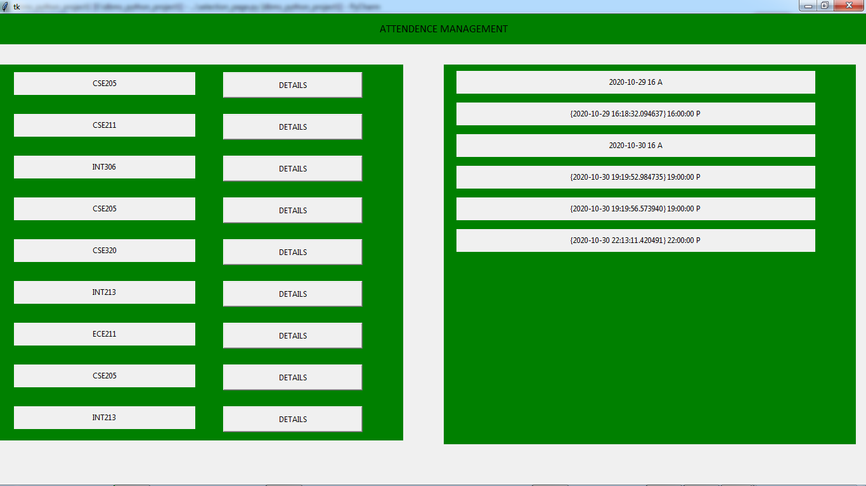

APPLY FOR LEAVE

- This Page is dedicated for student who want to apply for leave.
- Student will be asked for certain information mainly name,regno and reason for leave along with submit Button.
- Once user fill all information, and Submit the details, user’s status for that time will be changed to L->’LEAVE’

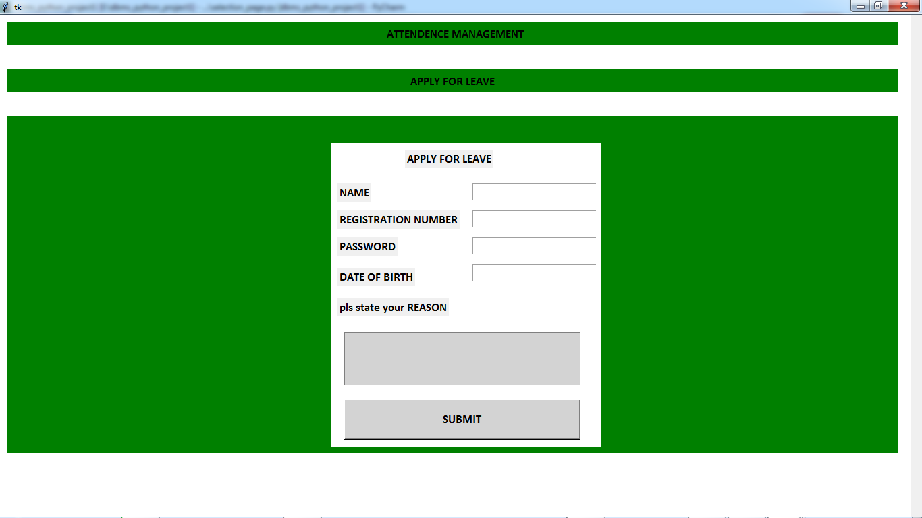

UPDATE PASSWORD

- This page is dedicated for managing password of the user.
- User will be asked fro registration number and old password.
- If registration number and password match, user will be directed to next page asking for new password and verify the entered password.
- If the entered passwords matches, then the change will be committed and saved.
- If Entered Data doesn’t match, user will get an error message.

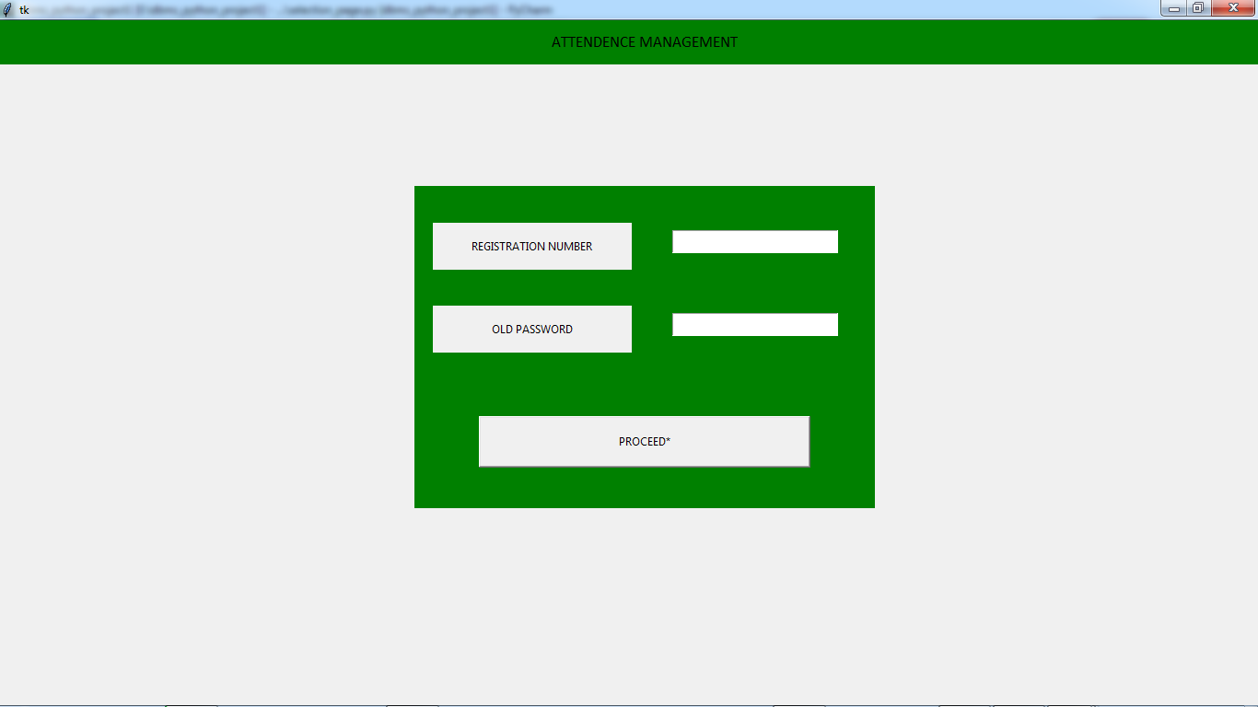

Log-out

- After clicking the logout option, user will be discontinued from that point and root Frame will be destroyed.

TEACHER’S SELECTION PAGE

- A after successfully logging in as a Teacher, user will be directed to the TEACHER SELECTION PAGE.
- TEACHER SELECTION PAGE mainly provides the choices in between functionality provided to the USER as a TEACHER.
- TEACHER SELECTION PAGE contains following options:-
  - DASHBOARD.
  - TODAY’S SCHEDULES
  - UPDATED TODAY’S SCHEDULES.
  - STUDENT ATTENDENCE.
  - APPLY FOR LEAVE.
  - LOG-OUT.

TEACHER SELECTION PAGE

APPLY FRO LEAVE
STUDENT ATTENDENCE
UPDATE TODAY’S SCHDEDULE
TODAY’S SCHEDULE
DASHBOARD

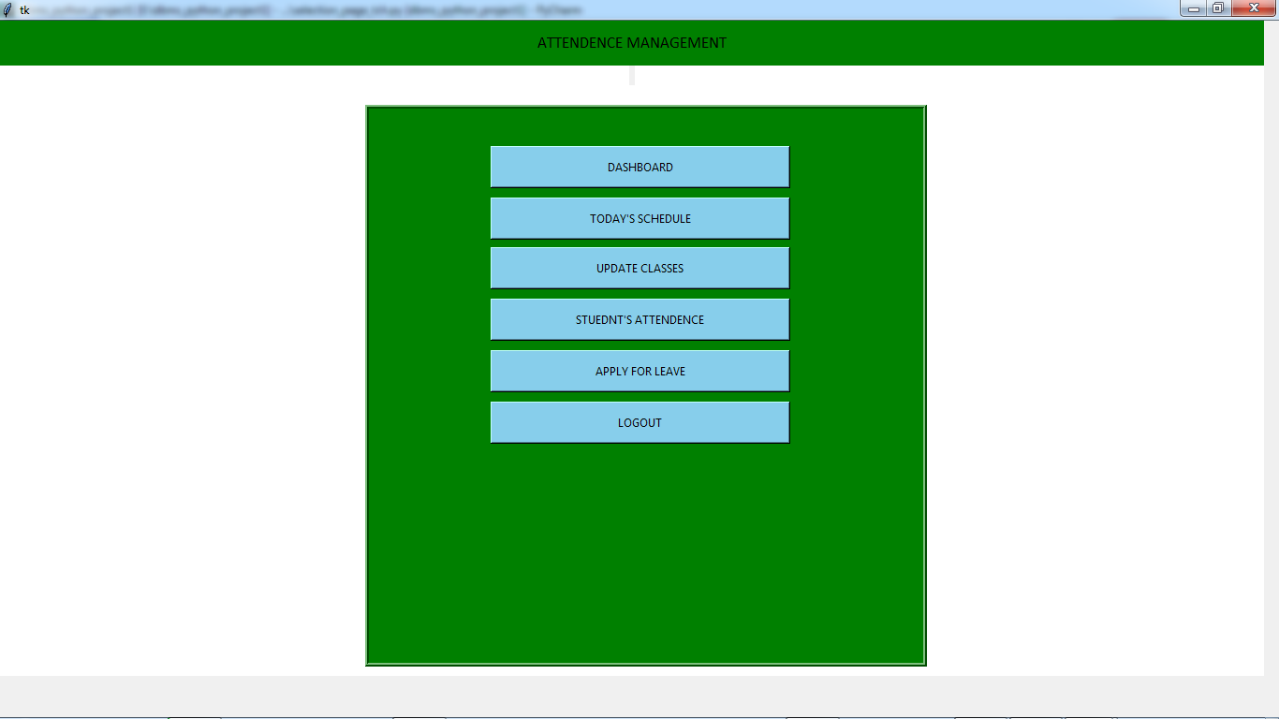

(teacher selection page)

TEACHER SELECTION

DASHBOARD.

- TEACHER’s Dashboard mainly contain all the required information of the user which includes:-
  - User’s name along with registration number and roll number.
  - User’s Course and session he/she enrolled in.
  - User’s selected profile picture.
  - A Quote for daily motivation.
- A Frame directly dedicated for:-
  - easy access to TODAY’S CLASSES SCHEDULED(timetable for classes our user needed to take.)
  - A Frame directly dedicated fro easy access to news and announcement (In case if any).
  - User’s class, news and attendence will directly be managed without user’s concern.
- User will also be shown:-
  - DATE for next holiday.
  - DATE for next CA.
  - DATE for Mid-Term.
  - Date for End-Term.
  - Please note that, admin has to manually feed this thing up.
- User will also be shown a message box to receive any message in case, from faculty OR STUDENT.
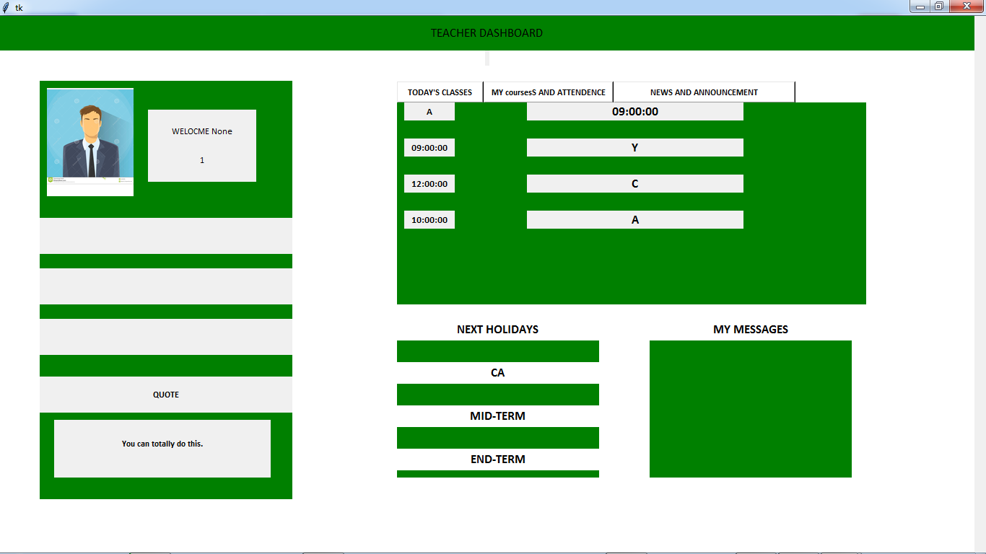
(teacher’s dashboard)
TEACHER SELECTION

TODAY’S SCHEDULES

- This page Is dedicated to see the schedule or the classes that Teacher has to take on that day.
- At the starting, Teacher will be asked the day fro which he/she want to check the schedule.
- After selecting a particular day(Monday to Saturday) teacher will be shown Schedule fro respective day.

UPDATE SCHEDULE

- This page is dedicated for updating the schedule for the teacher as per there need.
- Through this page teacher can delete any class or add a new class.
- At the starting this page will ask to enter respective day(ranging from Monday to Saturday ).
- After selecting a particular day, user will be directed to all the classes scheduled on that day.
  - User will be provided with Starting time of class, section name along with delete Button.
- User also will be provided with an ADD button to add a new class on that day schedule.
  - User will be asked to enter timing and section and then click on proceed.
  - Once user has clicked on proceed, class will be added successfully.
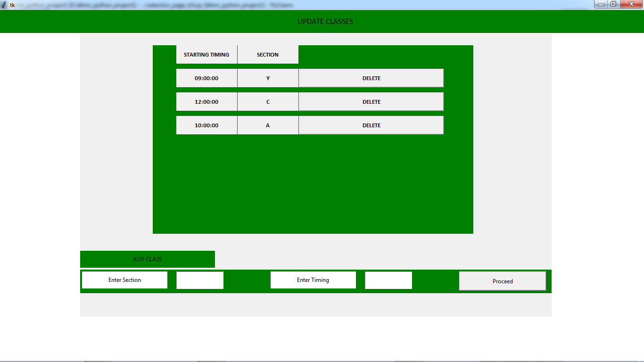
(update today’s schedule)

STUDENT ATTENDED THE CLASS.

- This page will show total student who were present in the class on that particular session.
- At the starting this page will ask from user to select day and select section who’s information teacher want to see.
- After proceeding, teacher will be provided with information of all the user along with user present in the class and user not present.
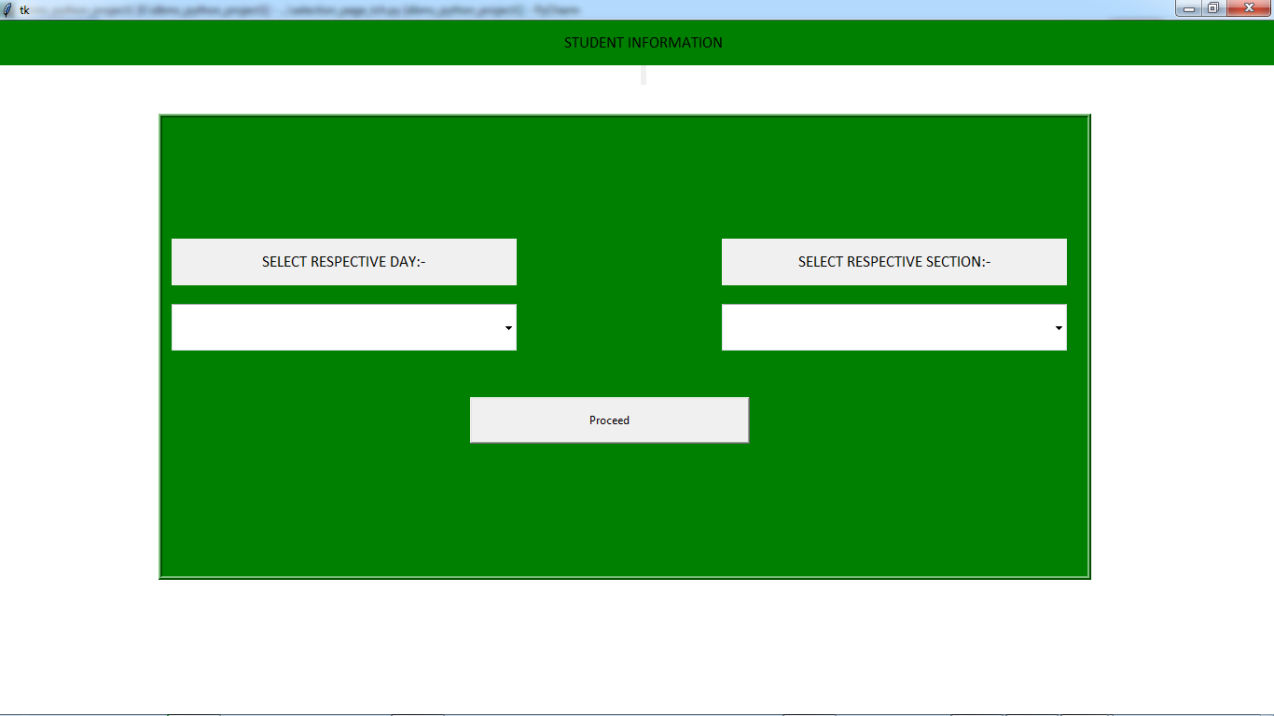

(data available)
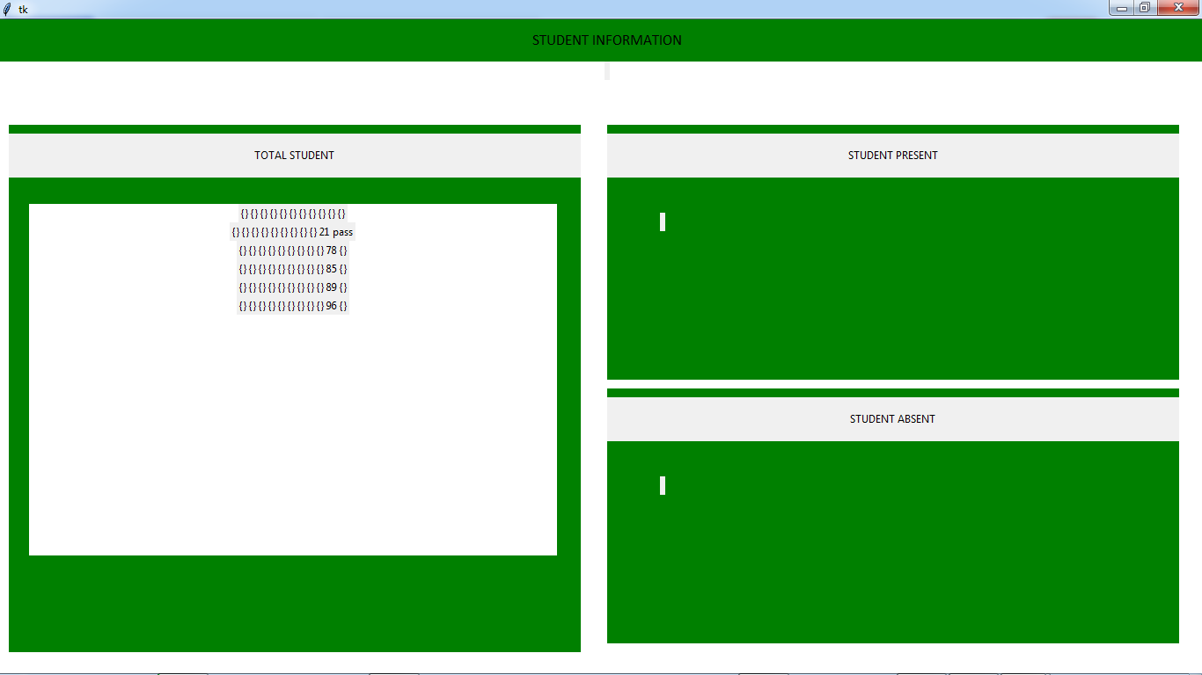

APPLY FOR LEAVE

- This Page is dedicated for teachers who want to apply for leave.
- teachers will be asked for certain information mainly name,regno and reason for leave along with submit Button.
- Once user fill all information, and Submit the details, user’s status for that time will be changed to L->’LEAVE’

Log-out

- After clicking the logout option, user will be discontinued from that point and root Frame will be destroyed.

ADMIN’S SELECTION PAGE

- After successfully logging in as a ADMIN, user will be directed to the ADMIN SELECTION PAGE.
- ADMIN SELECTION PAGE mainly provides the choices in between functionality provided to the USER as a ADMIN.
- ADMINSELECTION PAGE contains following options:-
  - DASHBOARD.
  - STUDENT INFORMATION.
  - TEACHERS INFROMATION.
  - ADD NEW USER.
  - UPDATE PASSWORD.
  - LOG-OUT.

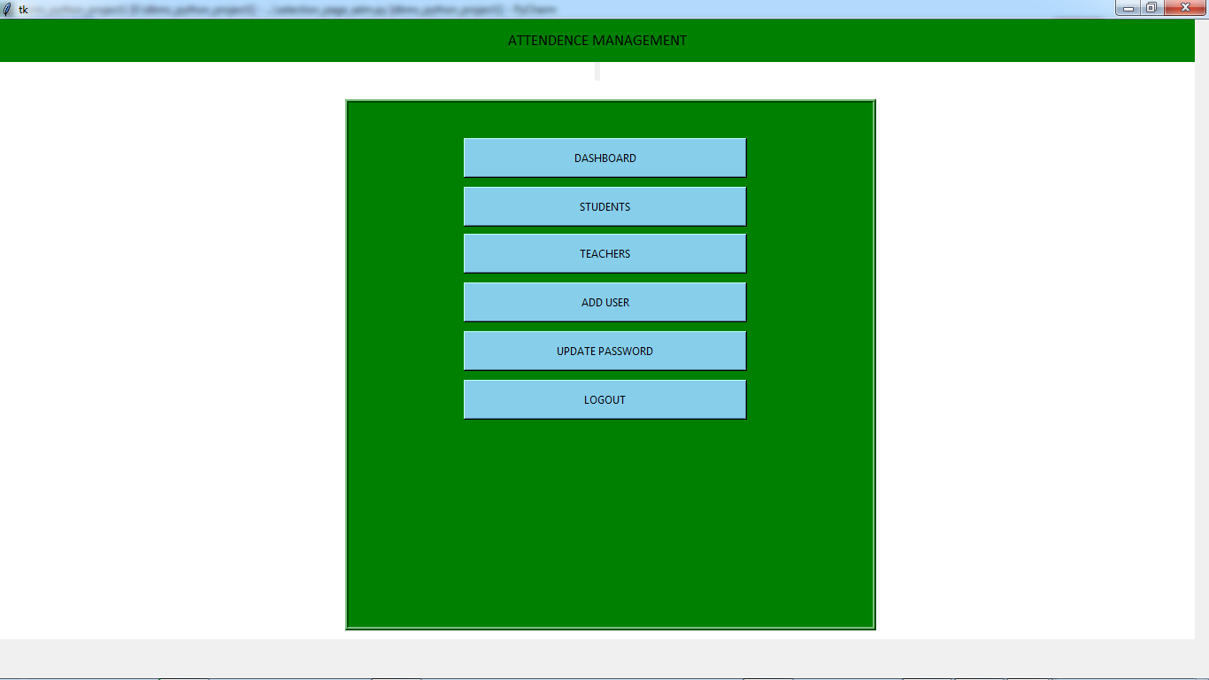(admin-’s selection page)
ADMIN SELECTION

DASHBOARD.

- ADMIN’s Dashboard mainly contain all the required information of the user which includes:-
  - User’s name along with registration number and roll number.
  - User’s Course and session he/she enrolled in.
  - User’s selected profile picture.
  - A Quote for daily motivation.
  - A Frame directly dedicated for:-
  - A Frame directly dedicated fro easy access to news and announcement (In case if any).
- User will also be shown:-
  - DATE for next holiday.
  - DATE for next CA.
  - DATE for Mid-Term.
  - Date for End-Term.
  - Please note that, admin has to manually feed this thing up.
- User will also be shown a message box to receive any message in case, from faculty.
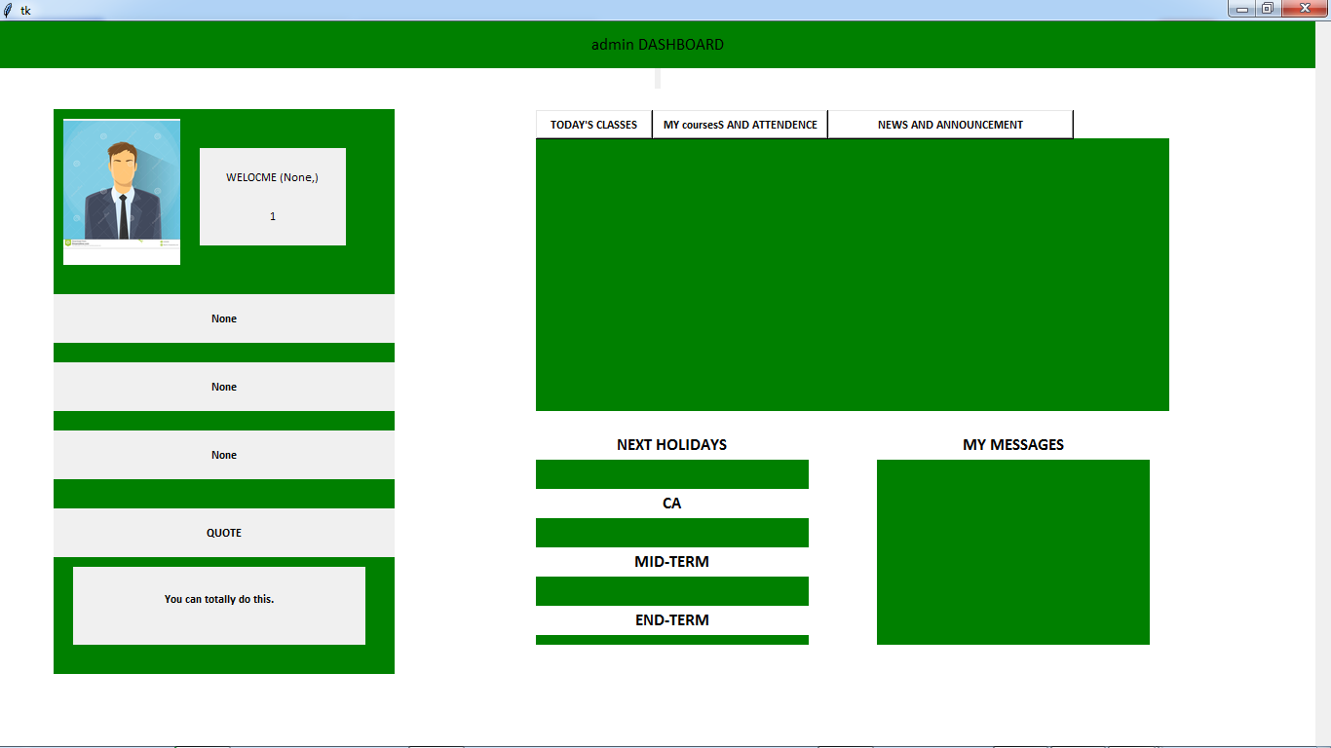(admin’s dashboard)
ADMIN SELECTION

STUDENT INFORMATION

- This is page contains all the information of student presented in the DATABASE.
- THIS PAGE is ONLY ACCESSED by ADMIN.
- This page provide admin power to delete any user or update any user’s information if needed.
- This page contains Frames of student NAME AND REGISTRATION NUMBER along with update Button and Delete Button.
- After clicking on Update Button user will directly transfered to next page which contain different Button mentioned as:-
  - Name
  - Registration number
  - Contact number
  - Email
  - Address
  - Password.
- If the user click on any of the Button mention above, Admin will get power to update this information.
- ADmin will also be provided with the old data and and will be asked to enter new data.
- Once the proceed Button will be clicked, user data will be Updated.
- After clicking Delete Button present in(point 4) Admin will successfully delete the data and and data Frame will get Update next time when user loggin.
- Admin will be informed by message Button fro the same.

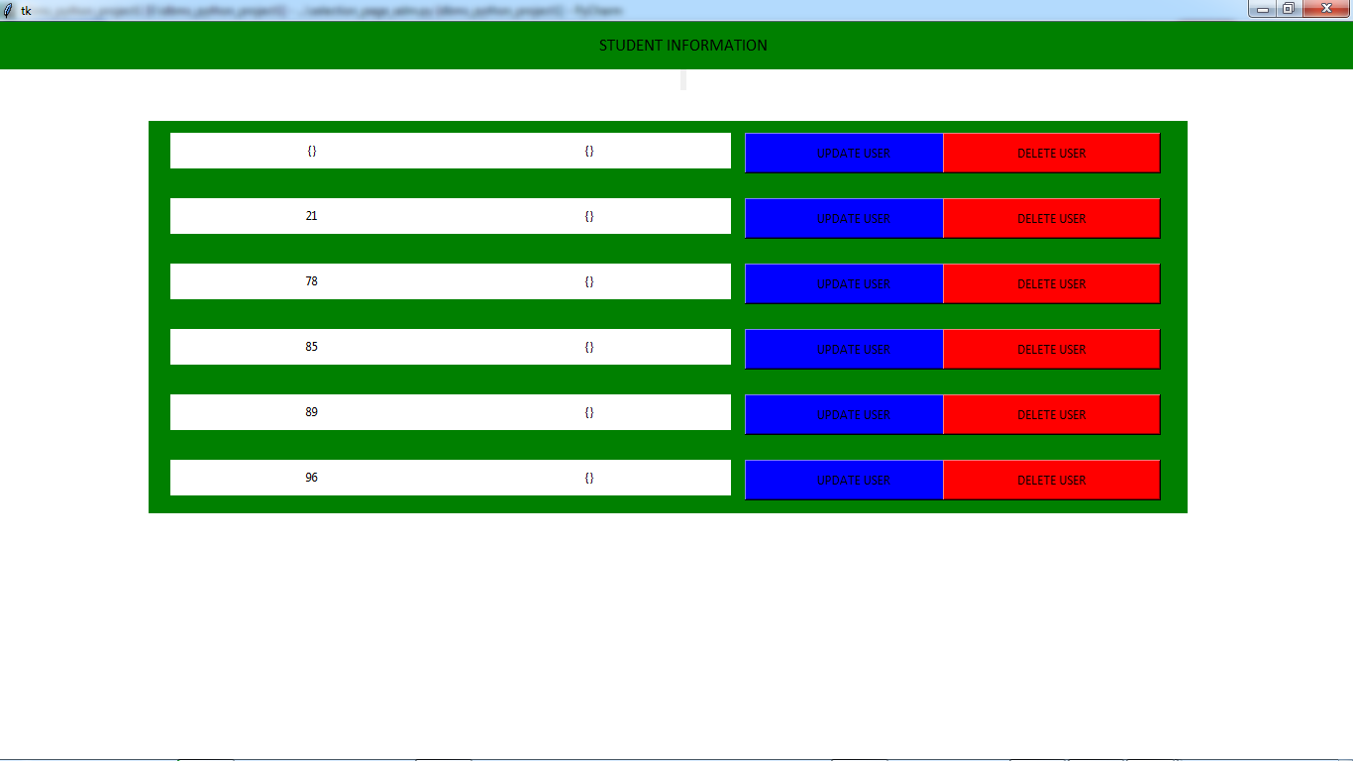

(ALL STUDENTAND TEACHER DATA AVAILABLE)

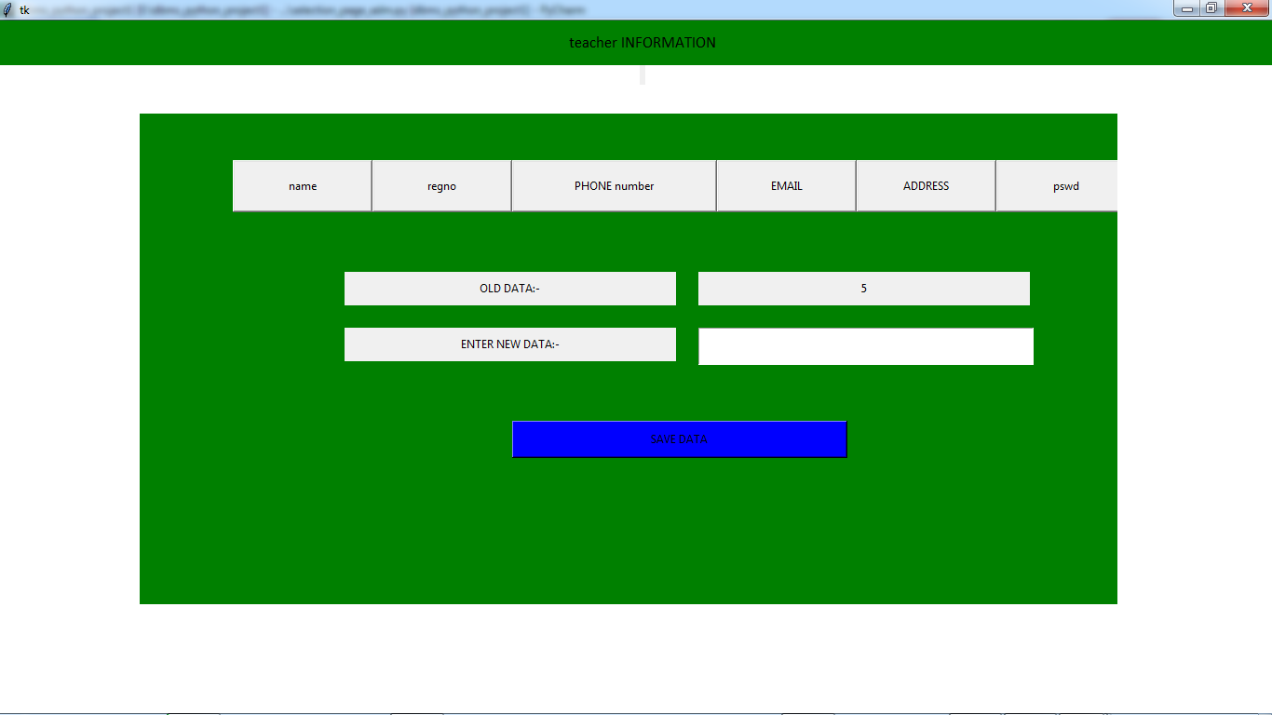

(AFTER UPDATE COMMAND)

ADMIN SELECTION

TEACHER INFORMATION

- This is page contains all the information of Teacher presented in the DATABASE.
- THIS PAGE is ONLY ACCESSED by ADMIN.
- This page provide admin power to delete any user or update any user’s information if needed.
- This page contains Frames of Teacher NAME AND REGISTRATION NUMBER along with update Button and Delete Button.
- After clicking on Update Button user will directly transfered to next page which contain different Button mentioned as:-
  - Name
  - Registration number
  - Contact number
  - Email
  - Address
  - Password.
- If the user click on any of the Button mention above, Admin will get power to update this information.
- ADmin will also be provided with the old data and and will be asked to enter new data.
- Once the proceed Button will be clicked, user data will be Updated.
- After clicking Delete Button present in(point 4) Admin will successfully delete the data and and data Frame will get Update next time when user loggin.
- Admin will be informed by message Button for the same.

ADMIN SELECTION

ADD NEW USER

- This page will empower Admin with Adding new user mainly as Student or Teacher.
- This page is available only for user as Admin.
- At the starting this page will ask regarding the type of user:
  - Student as new user.
  - Teacher as new user.
- Once user has selected User as Student, Admin will directly get transferred to new window where required personal information will be feeded and saved, once complete details where saved, new student will be saved.
- Similarly,Once user has selected User as Teacher, Admin will directly get transferred to new window where required personal information will be feeded and saved, once complete details where saved, new Teacher will be saved.

UPDATE PASSWORD

- This page is dedicated for managing password of the user.
- User will be asked fro registration number and old password.
- If registration number and password match, user will be directed to next page asking for new password and verify the entered password.
- If the entered passwords matches, then the change will be committed and saved.
- If Entered Data doesn’t match, user will get an error message.

Log-out

- After clicking the logout option, user will be discontinued from that point and root Frame will be destroyed.
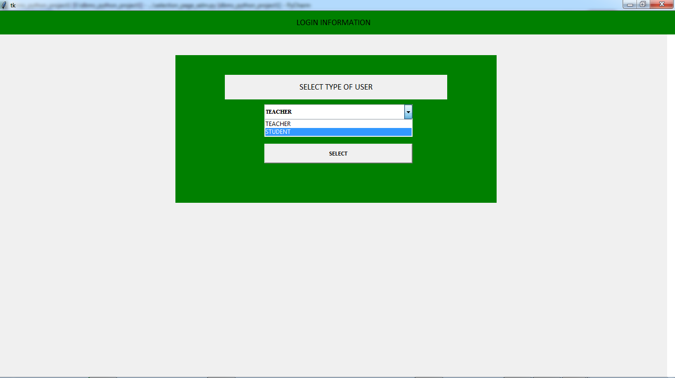
(ADD NEW USER)

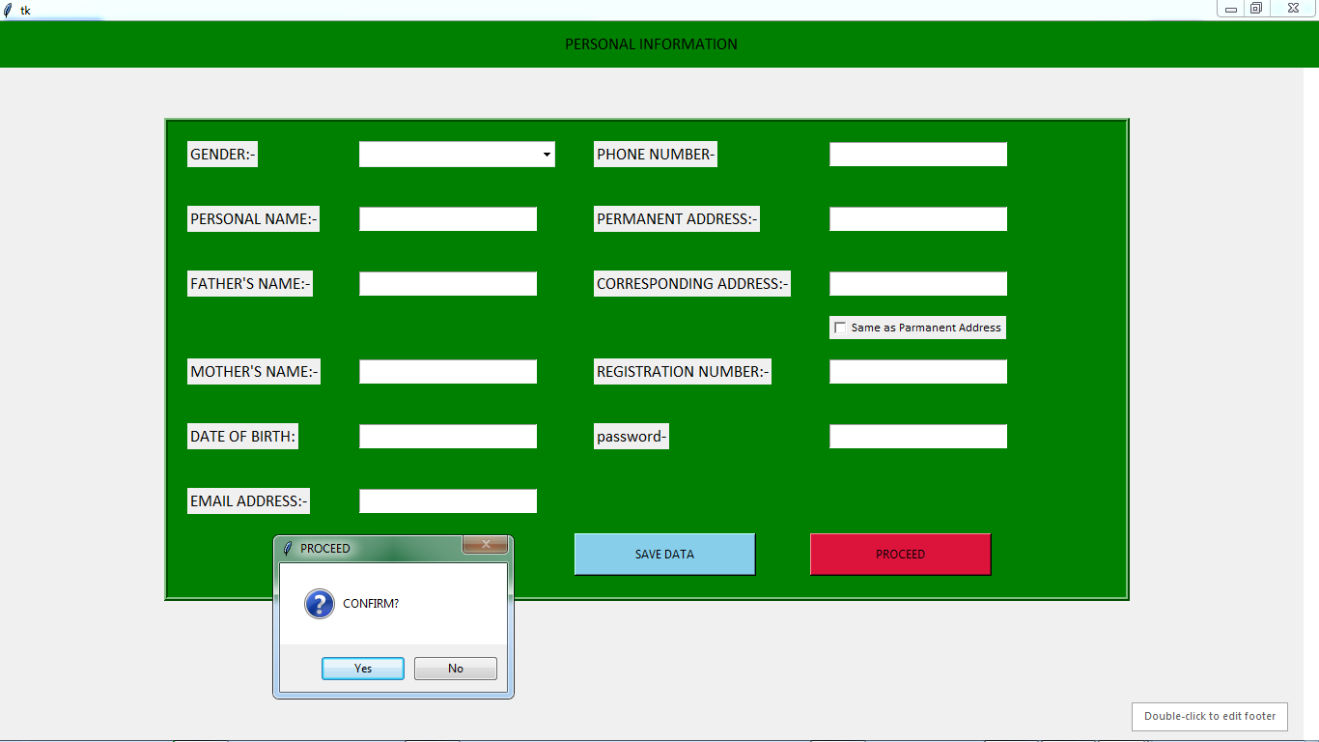

(TAKING INFROMATION AND SAVING AFTER CONFIRMING)

IMPORTANT FILE NAMES

File name work
Starting_page.py ->THIS IS THE STARTIN OF PROJECT.
LOGIN_SIGNING.PY -> OPEN LOGIN_SIGNING PAGE.
SELECTION_PAGE.PY -> STUDENT SELECTION PAGE
SELECTION_PAGE_TCH ->TEACHERS SELECTION PAGE
SELECTION_PAGE_ADM -> ADMIN’S SELECTION PAGE.
DASHBOARD.PY ->STUDENT DASHBOARD
DASHBOARD_TCH.PY -> TEACHERS DASHBOARD
DASHBOARD_ADM.PY ->ADMINS DASHBOARD
LEAVE.PY ->EAVE APPLICATION

ATTENDENCE.PY -> CHECK ATTENDENCE

UPDATE PASSWORD ->UPDATE_PSWD.PY
SCHEDULLING.PY -> CHECK FOR SCHEDULLING
UPDATE SCHEDULLING -> UPDATE_CLASS.PY
STUDENT_INFO.PY ->FOR STUDENT INFO IN TEACHER’S PAGE.
STUDENT_ADM.PY ->ADMIN TO UPDATE STUDENT.
TEACHER_ADM.PY ->ADMIN TO UPDATE TEACHER.
ADD_USER_ADM.PY ->ADMIN TO ADD NEW USER.
UPDATE_PSWD_ADM.PY -> ADMIN TO UPDATE OWN PASSWORD.

